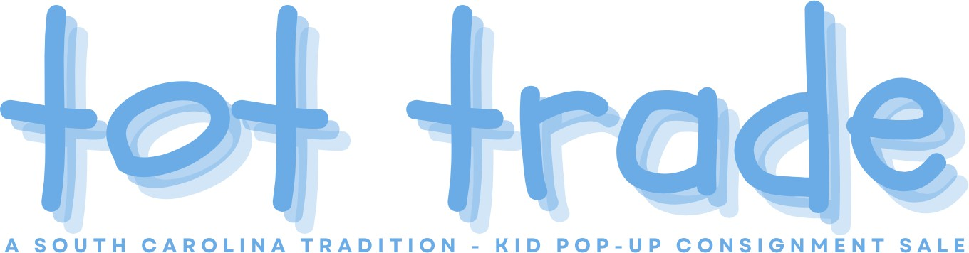
Tot Trade Boutique Brands List
If you are consigning boutique brands with us this season, this list will be helpful. This list is not all-inclusive but will give you a good idea of the brands we include in our boutique section of the clothing racks.
**Use this list as a guide. Send us an email if you don’t see your label
on this list but feel it is boutique.

A/B - Agatha Ruiz de la Prada, Agnes B, Alice Kathleen, Allie Wade, Allison Rose, Alphabet Amanda Rose, Amiana, Amour d’Absorb, Anabelle’s Closet, Anais & I, And Then There was Jake, Andy & Evan, Angel, Angel Dear, Anthem of the Ants, Artwalk, Ashton Copper, Aster, Aunt Polly Auraluz, Austin & Ashley, Ave. Blu, Azul Swimwear, Alex Hudson, Appaman, Amanda Remembered - Anavini - Anita G - April Cornell - Attitude Pie – Auroluz, Babalooi, Babiators, Baby Baubles, Baby Dior, Baby Gassy Gooma, Baby Graziella, Baby Luigi, Baby Lulu, Baby Nay Baby Noomie, Baby Sara, Baby Talavera, Baby’s in Bloom, Backflips, Bailey Boys, Bailiey Buddies Balenciaga, Balu, Bamba Kids, Banana Cabana, Banana Split, Be Mine, Beanstalk Originals, Beaufort Bonnet Company, Beaux et Belles, Bebe Mode, Bebemonde, Beetlejuice, Bela & Nuni, Bella Bliss, Bella Tunno, Belle Ame, Belle Enfant, Benetton, Berlingot, Best Friends, Betsy Johnson, Betti Terrell, Bienvenue sur Terre, Big Citizen, Big Fish, Biscotti, Blu by Blu, Blue Moon Blumarine, Bluebird, Bobby Mack, Bobby, BoBo Choses, Boden, BonBon, Botacelli, Bow Peep, Bowie James, Boys ‘n Berries, Brother and Sissy, Bufi, Bunnies by the Bay, Burberry, Busy Bees
Butterfly Kisses, Bella Lillie – Be Mine - Baby Brooks, Baby Lulu, Baby Sara, Bailey Blossoms, Blush by Us Angels, Bonnie Jean, Brooks Brothers, Burberry

C - Cabana Life, Candyland Kids, Caramelo, Carbone, Carlotta, Carolina Baby, Carriage Boutiques Castles & Crowns, Catamini, Cavalli, C’est La Vie, Cach Cach, Charlie Rocket, Crew Cuts, Cutie Couture, Cakewalk - Chatti Patti, Che!, Chevignon, Chez Ami, Chez Belle, Chick Chat, Chichanella Bella, Chicken Noodle, Chloe, Chocolate Soup, Christina Rohde, Christian Dior, Christian Lecroix Chabre –Cherise, Ciao Bella, Citizens of Humanity - Claire & Charlie, Classy Couture - Clayeaux -

Clo Clo, Coastal Projections, Coccoli, Coco Bonbons, Collection Bebe, Comptoir des Cotonniers, Confetti, Corky & Company, Cotton Kids, Cottontail Originals , Creme De La Crème, Crewcut/J.Crew, Cukees, Cupcake Originals, Cute as a Button, CWD Kids, Cyrillus

D/E - Delton, Deux Par Deux, DKNY, DotDotSmile, Da lil guys - Danica and Dylan - Deux par Deux
- Dogwood Boys, Egg Baby - Elebini - Elle - Ella Jackson, Eleanor Rose, Elisa B, English Rose
F - Fantaisie Kids - Feltman Brothers - Flapdoodles - Flaphappy - Florence Eisman - Floriane -
Freidknit Creations - Funtasia Too , Finn & Emma, Fiveloaves Twofish, Fore!, Freshly Picked,
Fromage et l’orange
G/H - Glorimont - Gordon & co - Gossip Girl - Greggy Girl , Gator Tagon, Giggle Moon, Hanna Andersson - Hannah Banana - Hannah Kate - Haute Baby - Haven Girl - Highland Porch - Hollywood Baby - House of Hatten, Hartstring, Haute Baby, Hudson
I/J - Icky Baby - IKKS - Imp Originals - Indygo Artwear - Isabel Garreton, Isabella & Chloe, Jacadi - Jack & Teddy - Janie and Jack - Jean Bourget - Jottum - Just Ducky, Jean Bourget, Jelly the Pug, Joah Love, Joe’s Jeans, Joy Folie,
K - Kanz - Kash Ten - Kate Mack - Keedo Clothing - Kelly’s Kids – Kenzo - Kids by M.E. - Kissy Kissy
Keen Shoes, Kiddo, Kirei Sui, Kitty Kat, KPea Original
L - Laura Dare - Lavender Blue - Le Cirque - Lili Gaufrette - Lilly Pulitzer - Lipstik - Little English -
Little Mass - Little Threads - Little Zazzy - Lola et Moi - Luli & Me - Luna Luna , Laura Ashley, Le Pink, Le Top, Lil Cactus, Lipstick Girls, Little Mass, Lolly Wolly Doodle
M - Marese - Maria Elena - Mary James - Matilda Jane - Me Too - Mimi & Maggie – Mini Boden -
Miniman - MISH MISH - MIS-TEE-V-US - Mom and Me - Monday’s Child - Mulberribush - My Vintage Baby , Maggie & Zoe, Mayoral, Misha Lulu, Miss Priss, Mud Pie, Mulberry Bush, Mustard Pie
N/O - Naarjtie - New Potatoes , Neiman Marcus, Oilily - One Kid - Ooh La La Couture - Oopsy
Daisy Baby - Orient Expressed, One Kids, Over the Top
P - Pampolina - Patsy Aiken - Peaches n' Cream - Petit Ami - Petit Lem - Petite Patapon- Pink
Ginger by Plum Pudding – Pink Tangerine - Plum Pudding/Marmalade - PotatoSaks
Persnickety, Pink Rock, Piper & Posie, Pipperdoodles, Pitter Patter, Polka Dots, PPLA, Pretty Me, Principessa

Q/R - Ragsland - Remember Nguyen - Room Seven - Rosalina - Royal Child - Rubbies , Rabbit
Moon, Rebel Kids, Red Sound, Ruffle Butts
S - Sarah Louise - Secret Wishes - Sew Blessed - Shrimp & Grits - Silly Goose – Sir John - Sister
Sam – Smartie Britches - Sophie Catalou - Sophie Dess - Sorbet - Strasburg - Submarine - Sucre
d’orge - Sweet Angela - Sweet Potatoes, Sado, Savannah, Serendipity, Stella M’Lia,
T/U - Tea - Tralala - Three Mommas - Trish Scully - Twirls and Twigs, Tea Collection, Tesa Baby,
Tesutio, The Good Ones, Tru Luv, Truly Me, UMI, Un Deux Trois, Us Angels
V/W - VictoriaKids - Vive La Fete ,Vera Bradely Baby, Well Dressed Wolf, Wildflowers, Will’beth
- Wish Upon a Star
X, Y, Z - Za Za Couture - Zackali – Zuccini , Zara Kids

